Risk Evaluation for Automatic Revolving Doors

1. Purpose of the Risk Evaluation

EN 16005 describes the safety requirements placed on automatic door systems as required by Directive 2006/42/EC (the Machinery Directive). The expected risks and the measures to eliminate or minimise these risks must be recorded. The risk analysis should be compiled with the involvement of the planner, operator and manufacturer.

The responsibility for product safety rests entirely with the manufacturer of the complete door system, in other words with the TORMAX sales partner or the TORMAX market organisation.
The Machinery Directive requires that a risk assessment and the accompanying safety measures must be prepared for every automatic door system.

2. Procedure

The TORMAX sales partner or the TORMAX market organisation, as manufacturer of the complete door system, complete the risk analysis as early as the planning stage and check the details based on the actual installation situation. This document is retained by the sales partner and forms part of the files on the door system.
Under the Machinery Directive, TORMAX sales partners and market organisations, as the manufacturer of the complete door system, are obliged to issue a declaration of conformity (document template T-1948 available in the Extranet) for the entire door system. The TORMAX declaration of incorporation and the completed risk assessment constitute the documents necessary for the issue of the declaration of conformity.

3. System Data

Please complete with all details.

Project type:
Location:
Contact person:
Address:
Street:
Town/city, post code:

Risk Evaluation carried out by:
Company:
Address:
Person: Date: ……………………………….

Door drive used:
Installed by: (Name, person installing the system)
System in use from (date):

4. Identification of the Risks

The elimination of a hazardous area is to be preferred over protection against a hazardous area.

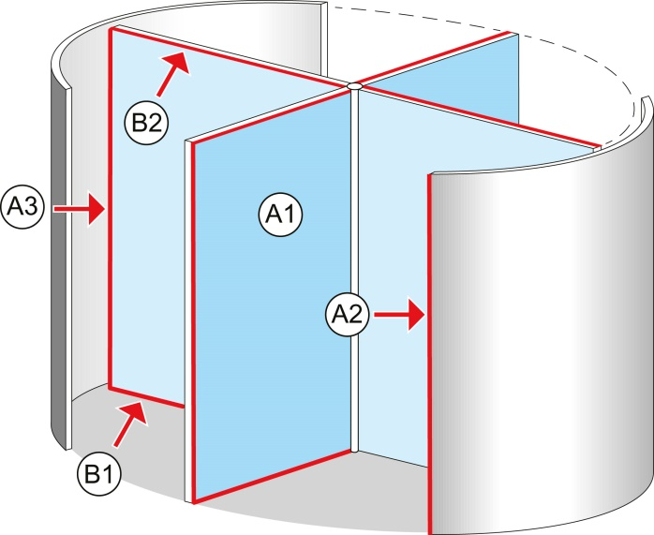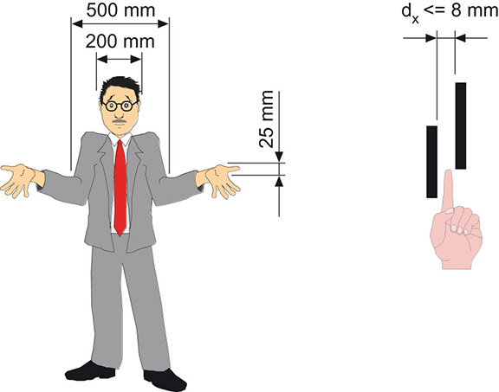
Clarification of safety distances
A = Main closing edge
B = Secondary closing edge

5. Risk Evaluation

Please tick the appropriate box.

Location / User

Public Area ( high risk):
Everybody, including particularly vulnerable persons

Non-public Area ( low risk):
Instructed personnel, access control

Suitable protective measures see chapter 6.

6. Suitable Protective Measures for Reducing the Risk on Revolving Doors
In accordance with EN 16005, chapter 4.6, 4.7, addendum C, addendum H

Please tick the selected protective measures:

A1 SAFEGUARDING AGAINST BUMPING INTO A DOOR LEAF
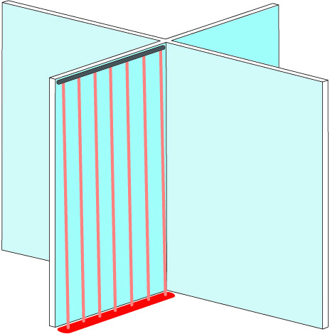
Public Area and Non-public Area
Risk accepted | On small door diameters | Planned protective measure  Installed protective measure
or
Safety Sensor with  monitoring | Diameters of > 3000 mm, monitored presence sensor, adjusting permitted only after 30 sec. | Planned protective measure  Installed protective measure
or
Laser scanner | As appropriate, test 4 with test bodies CA and CB together (Figure C.7, C.8 or C.9 from appendix C) | Planned protective measure  Installed protective measure

A2 SAFEGUARDING THE MAIN CLOSING EDGE – COLUMN
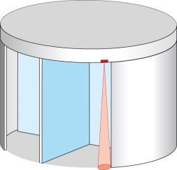
Public Area and Non-public Area
Pre-column safety | Monitored presence sensor, adjusting permitted only after 30 sec.. | Planned protective measure  Installed protective measure
and
Vertical strip sensor | min. 180° angle of response | Planned protective measure  Installed protective measure
and
Speed limit | Dynamic force max. 400 N  Static force max. 150 N  V max. 70 cm/s | Planned protective measure  Installed protective measure
or
Very low speed | Dynamic force max. 150 N | Planned protective measure  Installed protective measure

A3 SAFEGUARDING THE MAIN CLOSING EDGE – INNER DRUM WALL
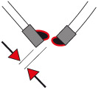
Public Area and Non-public Area
Vertical strip sensor | On leaf min. 180° angle of response | Planned protective measure  Installed protective measure
and
Safety distance | min. 25 mm | Planned protective measure  Installed protective measure

B1 SAFEGUARDING THE SECONDARY CLOSING EDGE – FLOOR
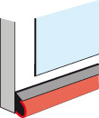
Public Area and Non-public Area
Horizontal strip sensor | Active strip sensor can be omitted, if energy is smaller 1,6 J (low energy),  F static < 67 N,  F dynamic < 150 N | Planned protective measure  Installed protective measure
or
Safety distance | max. 8 mm | Planned protective measure  Installed protective measure
or
Laser scanner | As appropriate, test 4 with test bodies CA and CB together (Figure C.7, C.8 or C.9 from appendix C) | Planned protective measure  Installed protective measure

B2 SAFEGUARDING THE SECONDARY EDGE – CEILING

Public Area and Non-public Area
Safety distance | No deepening in the ceiling  (avoid shear/crush zones) | Planned protective measure  Installed protective measure
or
Door height | > 2,5 m | Planned protective measure  Installed protective measure

7. Remarks

Changes of use, residual risks, special functions, miscellaneous
(Example of residual risks: moving parts in the area of all closing edges, objects positioned in the movement area of the door leaves, defective maintenance or no maintenance)

…………………………………………………………………………………………………………………………………………….
…………………………………………………………………………………………………………………………………………….
…………………………………………………………………………………………………………………………………………….
…………………………………………………………………………………………………………………………………………….
…………………………………………………………………………………………………………………………………………….
…………………………………………………………………………………………………………………………………………….
…………………………………………………………………………………………………………………………………………….
…………………………………………………………………………………………………………………………………………….
…………………………………………………………………………………………………………………………………………….
…………………………………………………………………………………………………………………………………………….
…………………………………………………………………………………………………………………………………………….
…………………………………………………………………………………………………………………………………………….
…………………………………………………………………………………………………………………………………………….
…………………………………………………………………………………………………………………………………………….
…………………………………………………………………………………………………………………………………………….
…………………………………………………………………………………………………………………………………………….
…………………………………………………………………………………………………………………………………………….
…………………………………………………………………………………………………………………………………………….
…………………………………………………………………………………………………………………………………………….
…………………………………………………………………………………………………………………………………………….
…………………………………………………………………………………………………………………………………………….
…………………………………………………………………………………………………………………………………………….
…………………………………………………………………………………………………………………………………………….
…………………………………………………………………………………………………………………………………………….
…………………………………………………………………………………………………………………………………………….
…………………………………………………………………………………………………………………………………………….
…………………………………………………………………………………………………………………………………………….

